The football season has started.
So get ready for the Flu season
Once again in September, the Grange, Kinsley & Greenview Medical Centres will be offering an extensive number of opportunities for patients to protect themselves, their family and community.
The flu jab cannot cause flu. A live virus is not used so you cannot catch flu from it. You may have a flu like virus, or may have caught flu before the vaccine has taken effect. It may take 10-14 days before you have full immunity.
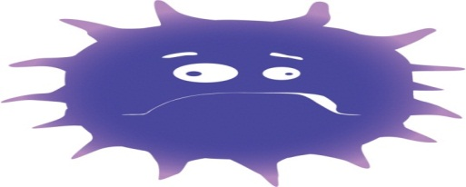
Thinking of paying, it may be free to you, so don’t rush out & buy the flu jab.
You are eligible:
If you are over 65 years of age;
Over 18 years of age and have a long term condition such as respiratory and heart conditions;
Similarly children aged six months to two years at risk of flu;
If you are pregnant;
Or, if you a care for someone.
If you are unsure, please contact the Reception.

Flu nasal spray vaccination will be offered to:
Healthy children aged two, three and four years old plus children in school years one and two & Children aged two to 17 years at a particular risk of flu.

The Flu Jab, it’s not just about you!
Those who catch the flu pass it on to an average of two people putting those most vulnerable at an increased risk including those with long-term health conditions and pregnant women.

