Are you a carer?

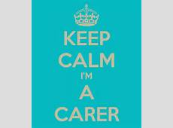
“A carer is anyone who cares, unpaid, for a friend or family member who, due to illness, disability, a mental health problem or an addiction cannot cope without their support.” Definition from ‘The Carers Trust’.
Useful Numbers & Information
Wakefield Carers | 01924 305544
Alzheimer’s Society | 01924 373264

The Carer Drop-in is at Hemsworth Library on the first Monday of every month between 10am and 12pm.
If you care for someone registered at the Grange, please tell reception. We can place this information on your record and offer appropriate support.
Antibiotic News

The world is on the cusp of a "post-antibiotic era", scientists have warned after finding bacteria resistant to drugs used when all other treatments have failed.
“Bacteria becoming completely resistant to treatment - also known as the antibiotic apocalypse - could plunge medicine back into the dark ages.” (James Gallagher, Health Editor, BBC News website - 19th November 2015).
So please do not be offended if we do not prescribe you antibiotics.
It is the bacteria and other microbes that become resistant to the drugs not people.
• Antibiotics do not work for ALL colds, or for most coughs, sore throats or earache. Your body can usually fight these infections on its own.
• Antibiotics are important medicines and should only be taken when prescribed by a health professional, and taken as directed. This includes finishing the course, even if you feel better.
Become an Antibiotic Guardian at http://antibioticguardian.com/

Please don’t request that we prescribe paracetamol.

Prescriptions for Paracetamol cost the NHS in Wakefield over £1 million last year.
Store’s Own Brand Paracetamol costs 24p for 16 tablets.

This saving would allow for the provision of either –

- 8,000 more GP appointments
- 125 knee replacements, or
- 1000 more treatments for dementia

Have you noticed this sticker around the Medical Centres?

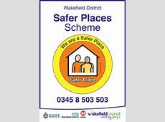
The Safer Places Scheme is a voluntary scheme that aims to assist vulnerable people with learning disabilities, autism and dementia to feel safer when travelling independently.
Vulnerable people who are members of the Safer Places Scheme carry a Safer Places Card with their name and the details of up to three people that can be contacted in the event that support is required.
If a vulnerable person arrives feeling unwell, confused, lost, or having been a victim of crime, staff within a Safer Place are asked to assist by contacting one of the people named on the back of the Safer Places Card, or the emergency services if necessary, and allow the vulnerable person to wait on the premises until the named person or police/ambulance arrive.
For more information please contact
0345 8 503 503 or visit www.wakefield.gov.uk & search for Safer Places.

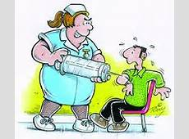
Meningococcal group ACWY vaccination programme launched
All adolescents born in England between 1 September 1996 and 31 August 1997 are eligible for this vaccination regardless of their future plans.
Where possible, it is important that anyone who plans to go to university for the first time this year gets vaccinated before they leave home, including overseas and mature students, up to 25 years of age. This group is at an increased risk of contracting meningococcal disease (Meningitis).

Shingles
Shingles can develop at any time following a chickenpox infection, and can occur in individuals of any age. However, the risk and severity of shingles increases with age.
So are you eligible for the Shingles Vaccine or know someone who is?

Aged 70 years on Sept 1st 2015

Or if you have not been vaccinated and are:

Aged 71 or 72 years on Sept 1st 2015
Or
Aged 78 or 79 years on Sept 1st 2015

Please contact Reception after 10am to check if you are eligible for either of these vaccinations. You can also check your eligibility for the flu vaccination.

