The Grange, Greenview & Kinsley Medical Centres
VIP Passport
This VIP Passport gives the surgery staff important information about you and will allow the surgery to meet your individual needs whenever we need to contact you or when you visit the surgery.
If you need help to fill this in, please ask a member of staff, your GP or nurse, a family member or friend.
ABOUT ME
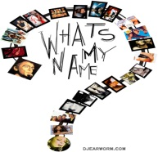 | My name …………………………………………………………………………….  Address ……………………………………………………………………  Date of birth ……………………………………..  Landline ‘phone number………………………………………….  Mobile ‘phone number……………………………………………  Are you happy for us to send reminder text messages to your mobile ‘phone number? Yes [ ] No [ ] Please tick  Do you have an email address you would like to give us?  …………………………………………………………………………….
If you write to me I need the information in this way;

Easy Read [ ] Large Print [ ] Email [ ]

Other, please specify …………………………………

About my sight ……………………………………………………………………
……………………………………………………………………………………..
………………………………………………………………………….................

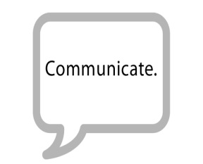 | When you talk to me I need the following assistance;  Hearing Loop [ ] British Sign Language Interpreter [ ]  Face to Face [ ] Makaton Interpreter [ ]  Other, please specify …………………………………..
About my hearing ………………………………………………………………..
……………………………………………………………………………………..
……………………………………………………………………………………..
Do you have a carer or someone who assists you with your visits to the surgery?
………………………………………………….……………………………

If so, what is their name? ……………………………………………..

Patient Reference Group - New members are welcome to join the patient reference group at any time - please leave your name and contact details at reception and we will be in touch...
WAYS TO CONTACT THE PRACTICE
Telephone: 01977 610009
Fax: 01977 617182
Web address; www.grangemedicalcentre.co.uk

If you want to request access to Online Services, please ask at Reception for an information pack or check our website for further information.

For Office Use Only:
Registered blind 6689
Visually impaired XE1T1
Deaf/hard of hearing XE0s9
Learning disabilities XaKYb

