It’s still not too late to protect yourself & loved ones.
The flu vaccine is still available free of charge for those patients over 65 years of age, with a long term conditions or are pregnant.

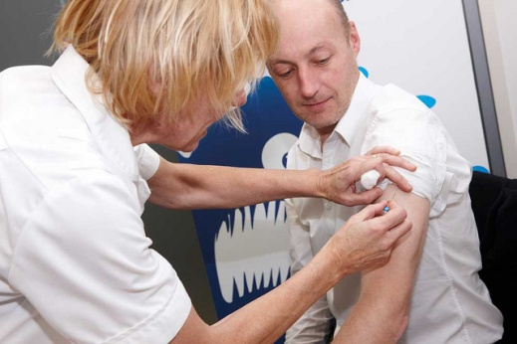
The chickenpox virus can stay in your body for life and if the virus reactivates it will return as: SHINGLES
The older you are the more painful it can be. So if you were aged 70, 78 & 79 on the 1st September 2014

PLEASE CONTACT RECEPTION TO MAKE AN APPOINTMENT

Sometimes no news is good news
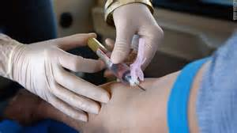

When your Doctor or Nurse has requested that a blood sample is taken the results will be reviewed. If further tests are required your Doctor or Nurse will contact you. If the results are satisfactory you will not hear from us.
Are you a carer of someone with Dementia?

If you are, please inform the reception and who it is that you are a carer for. This will allow the Practice to offer you a Health Check the next time you see a Doctor or Nurse and we may be able to offer you support or direct you to someone who can help.

Patient Reference Group

Join the group and meet existing members who have worked with the Practice to improve the patient experience. Every 6 weeks we meet to discuss how we can continue working together to provide the best care possible to you & your family.
If you are interested, please contact the Practice for more details.

