Apologies
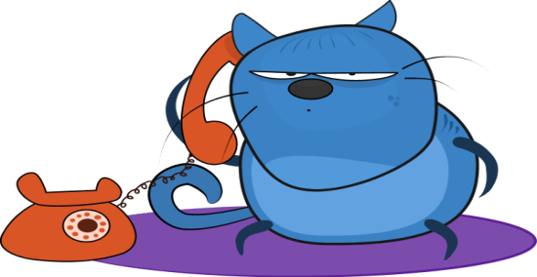
Many of our patients will be aware that we have recently installed a new, more modernised telephone system, and we hope that our patients will now find it easier when contacting the surgery by telephone. There is now only one telephone number which is answered by staff across all three sites, with appointments still being offered at the site most convenient to the patient.
Unfortunately, the transfer to the new telephone system resulted in unforeseen difficulties, namely that all telephone calls were coming direct to Hemsworth rather than being directed to all three sites. To help deal with this issue we did temporarily move more staff to Hemsworth, however, we do understand how frustrating it has been for our patients, and ultimately we realise that our service was well below reasonable levels, and for this we sincerely apologise.
We have been assured by the company that installed the new telephone system that these issues have now been resolved.
The Grange Medical Centre is committed to providing the best service possible for our patients, and we are confident that the new telephone system will improve access for all of our patients. We thank you for your continued patience.
Home Visits
Can the Practice respectfully request that patients requesting a home visit please consider if they have a friend or family member who could help them get to an appointment at the surgery. One less home visit can release the GP to be available for four additional appointments at the Practice. You may also be seen sooner. Thank-you.
We would like to remind patients that following any investigations requested by clinicians, we will only contact you if the GP/nurse needs to discuss these results. If they are satisfactory we will not routinely contact you, and you do not need to make an appointment.
The Expert Patients Programme

Persistent Pain Management

This course is specifically designed for people who are living with persistent, physical pain.

New Beginnings

The course runs over seven sessions and is aimed at people who are living with any mental health condition.

Each course is free and is provided by the NHS. It doesn’t interfere with any treatment you are currently receiving, as it compliments other healthcare programmes.

For more information, please contact the Self-Management Service on 01977 665732, or visit our Facebook page: www.facebook.com/ExpertPatients

Benzodiazepines and Z Drugs (Zopiclone/Zaleplon and Zolpidem)

These medicines were devised to help patients suffering with severe insomnia/sleeplessness and anxiety for short periods of time (NICE Guidelines). These drugs can have a number of side effects including: drowsiness the next day; interaction with alcohol and other medications; clumsiness and confusion when getting up in the night; reduced effectiveness and long-term dependency.
The Practice is therefore going to reduce the new prescribing of these drugs, unless the clinician feels that there is a clinical need. In this case the medication will be prescribed for no longer than 4 weeks.
We will also be reviewing the records of patients who have been prescribed these medicines, and will be reducing the dosage with a view to stopping the drug completely (unless there is a clinical need not to).
Carers Support Group

Information, advice & support for the carers of people with dementia.
This drop-in event is held at Hemsworth Library on the 1st Monday of the Month, from 10am to 12pm. Due to the Bank Holiday, the next meeting will be held on Monday 9th May from 10am to 12pm.

Want to learn more and become a Dementia Friend? Please attend at Hemsworth Library on 6th June from 12pm to 1pm. Tea and biscuits will be available.

